Ideation Phase
Brainstorm & Idea Prioritization Template

Date | 29 June 2026
Name | VARSHINI S
Project Name | Metro Ticket Generating System in ServiceNow
Maximum Marks | 4 Marks

Brainstorm & Idea Prioritization Template:
Brainstorming is a creative process used to generate innovative ideas byencouraging discussion, collaboration, and problem-solving among project stakeholders. During the development of the Metro Ticket Generating System in ServiceNow, brainstorming helped identify the major challenges faced by passengers in booking metro tickets, such as long queues, manual ticket processing, fare calculation errors, and lack of digital ticket verification. Multiple solution ideas were discussed to design a simple, secure, and automated ticket booking system.
Through brainstorming sessions, several concepts were evaluated, including online metro ticket booking through the Service Portal, automated fare calculation, QR code-based ticket generation, Flow Designer automation, secure passenger data storage, mandatory field validation, UI Policies, Catalog Client Scripts, and request status tracking. The ideas were then prioritized based on business value, implementation effort, user convenience, and future scalability. This collaborative approach ensured the development of an efficient, user-friendly, and maintainable Metro Ticket Generating System that improves passenger experience and reduces manual administrative effort.

Reference: https://www.mural.co/templates/brainstorm-and-idea-prioritization
Step-1: Team Gathering, Collaboration and Select the Problem Statement
The project team collaborated to identify the major issues in the existing metro ticket booking process. Discussions focused on understanding passenger requirements, operational challenges, and opportunities for automation. The team concluded that manual ticket booking leads to long waiting times, manual errors, and inefficient record management. The selected problem statement was to develop a ServiceNow-based Metro Ticket Generating System that automates ticket booking, fare calculation, request processing, QR code generation, and secure data management while improving user convenience.

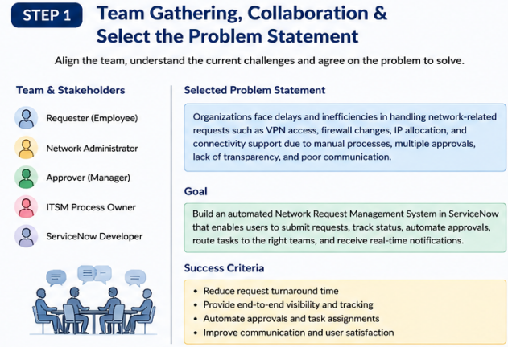

Step-2: Brainstorm, Idea Listing and Grouping
After identifying the problem statement, multiple solution ideas were generated and grouped into functional categories. Key ideas included:
- Service Portal-based Metro Ticket Booking
- Dynamic Source and Destination Selection
- Automatic Fare Calculation
- Journey Type Selection (Single/Return)
- Passenger Details Management
- QR Code Generation for Ticket Verification
- Flow Designer Automation
- Custom Metro Database Table
- Mandatory Field Validation
- UI Policies and Catalog Client Scripts
- Request Status Tracking
- Access Control for Secure Data Management
These ideas were evaluated based on feasibility, user experience, and implementation complexity.

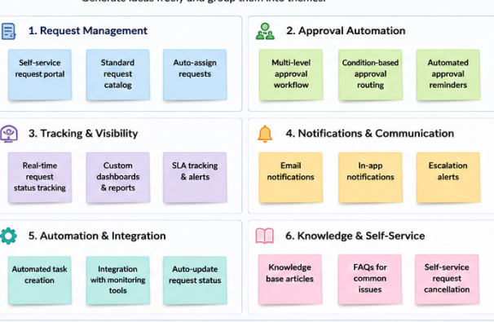

Step-3: Idea Prioritization
The shortlisted ideas were prioritized according to their business value and implementation effort. High-priority features included Service Portal ticket booking, Flow Designer automation, automatic fare calculation, secure passenger data storage, and QR code generation because they directly improve the passenger experience and automate metro operations. Medium-priority features included notifications, reporting, and request tracking, while future enhancements such as payment gateway integration, email ticket delivery, SMS notifications, travel history, and analytics dashboards were planned for future releases. This prioritization ensured that the core ticket booking functionality was completed successfully within the project timeline while allowing scope for future improvements.
